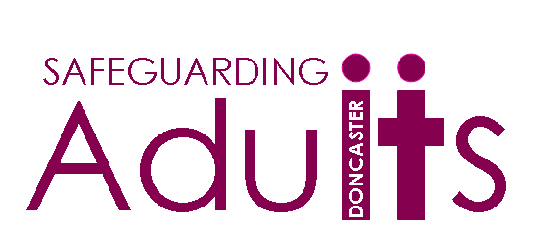
MCA/DOLS Classroom based Courses for 2017/18

Mental Capacity Act - (Basic Awareness)
22nd May 2018 | 13:30 – 16:30
5th July 2018 | 09:30 – 12:30
5th July 2018 | 13:30 – 16:30
11th September 2018 | 09:30 – 12:30
11th September | 13:30 – 16:30
13th November 2018 | 09:30 – 12:30
13th November 2018 | 13:30 – 16:30
30th January 2019 | 09:30 – 12:30
30th January 2019 | 13:30 – 16:30

Complex Decision making under the Mental Capacity Act
09:30 – 16:30
11th July 2018
14th December 2018

Mental Capacity Assessment and Affairs
09:30 – 16:30
11th June 2018
6th December 2018

Introduction to DOLS - (Basic Awareness)
09:30 – 16:30
2nd May 2018
10th July 2018
13th September 2018
7th November 2018
15th January 2019
6th March 2019

DOLs for Care Homes and Hospitals
09:30 – 16:30
5th June 2018
6th September 2018
16th January 2019

Other modules will be advertised in due course. Please visit the Safeguarding Adults webpage for details. http://www.doncaster.gov.uk/services/adult-social-care/what-safeguarding-adults-training-is-available

For bookings please use SEMINAR via the following link:

http://doncaster.learningpool.com/

